**Section A:**

**1.**

**User Needs:** The site needs to include information about the company and what they do. The information needs to be clear and readily available. The information needs to link to other pages on the site for easy navigation. The site needs to easily transition between various screen sizes and types of interaction. The site needs to give all the information the user needs to take care of their pet. **Stakeholder Needs:** The website design needs to include various colors and logos that identify the brand. Keywords that allow for top search results in search engines.

Microinteractions such as buttons changing colors on hover, shaded buttons that identify what page the user is on, and higher quality animations that give the site personality and make the site, and thus the company, feel higher quality.

The site must adhere to accessibility standards for colors, fonts, and navigation so as many users as possible can use and enjoy the site.  
  
The site must contain a form for users to contact “Pexperts” for further information about caring for their pets or information about the company.

**2.** The bird page will be selected as the new one page added to the site. This page will include all the information needed to keep their bird happy and healthy. The relational needs of birds are important as they are social and somewhat exotic animals.

The page will be easy to navigate on mobile or desktop just like the rest of the site.

**3.** The FAQ page should be removed from the site.

**User Needs:** This page would be a confusing and disorganized section relating to various animals rather than having a page for each specific animal. If a user is looking for specific information about their pet, the information should be located somewhere the user expects rather than randomly distributed inside an FAQ page. The FAQ page goes against a user's need for information to be clear and readily available.

**Stakeholder Needs:** As the stakeholders need the site to have easy navigation this FAQ page goes directly against this. The FAQ page practically serves no more a purpose than a separate page for each animal would serve. Additionally, any extra information a user needs can be answered by a “Pexpert” in the provided form. Making the FAQ page redundant.

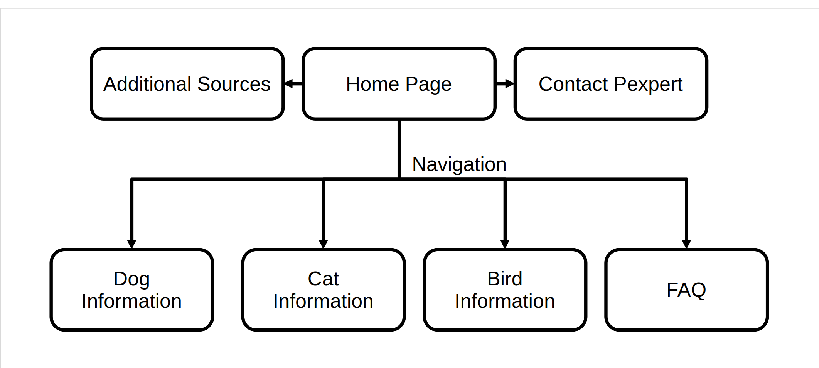**4.**

**5.** The main landing page for all users will be the home page with the ability to submit your contact information to contact a “Pexpert” to resolve any questions they may have. There will be additional sources for any new pet owners on the home page for anyone who is researching their pets needs. This will allow the user to know that the source is correct and valid. The homepage will contain general information about the company, its practices, and how it operates. Fulfilling the stakeholder and user needs.

Dog and Cat information pages will continue to exist though their information and layout likely will be updated. A Bird information page will be added to comply with the Bird Owner persona. The FAQ will no longer exist.

**6.** The primary navigational elements of the site include images that link to various pages around the site with labels.

The secondary navigational elements will be in the drop-down menu that will allow users to navigate the site to various pages about specific animals.

**a.  
 User Needs:** The users want the most useful and readily available information to them upfront. So, the ability to quickly and easily see which pet they have and need information on and go to that page allows for users to navigate the site without issues.

The drop-down menu will easily scale to various viewing configurations and is easy to navigate to find more specific information about their pet type. **Stakeholder Needs:** One of the primary goals is for users to stay on the site once they join. For this reason, the image will help with user retention as users will be able to easily find the information they are looking for.

The drop-down menu follows accessibility standards and allows for easy access to various pages across the site.

**Section B:**

